Lab Report : 06

The for Loop in C++

Objective

To understand the working of the for loop in C++ and demonstrate its use in performing repetitive tasks such as printing sequences, calculating sums, and controlling iterations.

Theory
- A loop is a control structure that allows repeated execution of a block of code.
- The for loop is an entry-controlled loop in C++.
- Syntax:
for (initialization; condition; update) {
// loop body
}
- Initialization: executed once at the beginning.
- Condition: checked before each iteration; if false, loop terminates.
- Update: modifies the loop variable after each iteration.

Algorithm
- Start the program.
- Initialize the loop variable.
- Check the condition: if true, execute the loop body; if false, exit.
- Perform the update expression.
- Repeat steps 3–4 until the condition becomes false.
- End the program.

Programs & Outputs

Example 1: Print Numbers 1–5
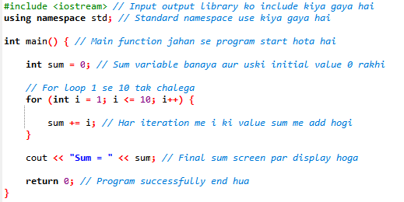
Output:
Code
1 2 3 4 5

Example 2: Sum of First 10 Natural Numbers
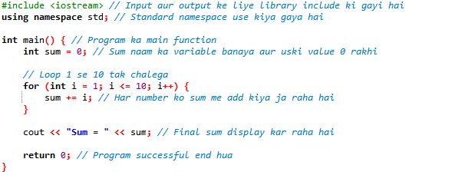
Output:
Sum = 55

Example 3: Countdown
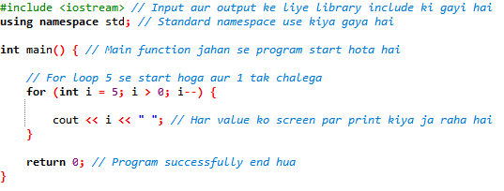
Output:
Code
5 4 3 2 1

Results
- The for loop successfully executes repetitive tasks with concise syntax.
- It is most effective when the number of iterations is known in advance.
- Different variations (incrementing, decrementing, skipping values) can be applied depending on the problem.

Conclusion
The for loop in C++ is a powerful construct for iteration. It allows initialization, condition checking, and updating in a single line, making programs more readable and efficient. It is widely used in scenarios like printing sequences, summing numbers, and performing repetitive calculations.

Lab Report Tasks:
Task (1):
For Loop
- Write a C++ program that uses a while loop to display numbers from 1 to
10.
- Display each number on a separate line.
Code:
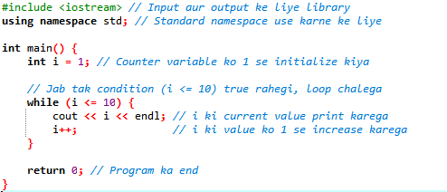

Task (2):
Nested for Loop : Multiplication Table
- Write a C++ program that generates a multiplication table from 1 to 10.
- Use nested for loops to iterate through the rows and columns of the table.
- Display the multiplication table in a formatted manner

Code:
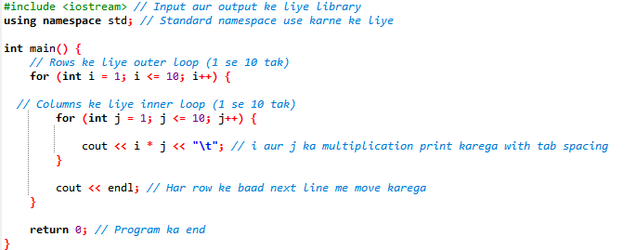
Task (3):
Sum using while Loop
- Write a C++ program that prompts the user to enter a positive integer.
- Use a for loop to calculate the sum of all numbers from 1 to the entered
- integer.
- Display the calculated sum.
Code:
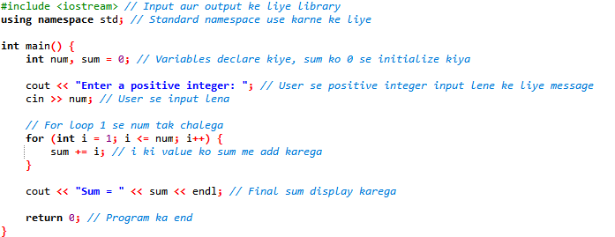
Task (4):
- Nested Pattern Printing using nested for loop
- Write a C++ program that uses nested for loops to print a pattern of
asterisks.
- The pattern should form a triangle shape, with each row having an
increasing number of asterisks.
- The number of rows in the pattern should be determined by user input.

Code:

